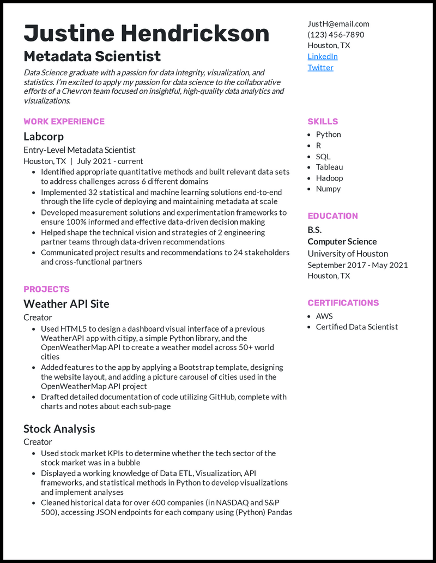
Justine Hendrickson
Metadata Scientist
Data Science graduate with a passion for data integrity, visualization, and statistics. I'm excited to apply my passion for data science to the collaborative efforts of a Chevron team focused on insightful, high-quality data analytics and visualizations.
WORK EXPERIENCE
Labcorp
Entry-Level Metadata Scientist
Houston, TX | July 2021 - current
• Identified appropriate quantitative methods and built relevant data sets to address challenges across 6 different domains
• Implemented 32 statistical and machine learning solutions end-to-end through the life cycle of deploying and maintaining metadata at scale • Developed measurement solutions and experimentation frameworks to ensure 100% informed and effective data-driven decision making
• Helped shape the technical vision and strategies of 2 engineering partner teams through data-driven recommendations
• Communicated project results and recommendations to 24 stakeholders and cross-functional partners
PROJECTS
Weather API Site
Creator
• Used HTML5 to design a dashboard visual interface of a previous Weather API app with citipy, a simple Python library, and the OpenWeatherMap API to create a weather model across 50+ world
cities
• Added features to the app by applying a Bootstrap template, designing the website layout, and adding a picture carousel of cities used in the OpenWeatherMap API project
• Drafted detailed documentation of code utilizing GitHub, complete with charts and notes about each sub-page
Stock Analysis
Creator
• Used stock market KPIs to determine whether the tech sector of the stock market was in a bubble
• Displayed a working knowledge of Data ETL, Visualization, API frameworks, and statistical methods in Python to develop visualizations and implement analyses
• Cleaned historical data for over 600 companies (in NASDAQ and S&P 500), accessing JSON endpoints for each company using (Python) Pandas
JustH@email.com
(123) 456-7890 Houston, TX
LinkedIn
Twitter
SKILLS
• Python • R
• SQL
• Tableau
• Hadoop • Numpy
EDUCATION
B.S. Computer Science
University of Houston September 2017 - May 2021 Houston, TX
CERTIFICATIONS
• AWS
• Certified Data Scientist

